
Technische Hochschule Deggendorf
Bayesian Sensor Fusion and Gaussian Process Mapping for
Human–Robot Collaborative Hygiene Monitoring and
Surface Disinfection
A Final Research Report
Submitted by:
Alwa Jyoshna (12503920)
Mahesh Kappala (22507453)
Vallepu Vishnu (2252290)
Course:
M.Engg. in Assistive Robotics
Under the Supervision of:
Prof. Dr.-Ing. Hamidreza Heidari
Date of Submission: 03.07.2026
Table of Contents

Abstract……………………………………………………………………………5
1 Introduction…………………………………………………………………......6
2 Literature Review……………………………………………………………….7
2.1 A Shared Autonomy Surface Disinfection System……………………………………………………………7
2.2 Verifiable Surface Disinfection Using UV Light…………………………………………………………………7
2.3 Vision-Based Mobile Manipulation for High-Touch Surfaces……………………………………………7
2.4 RODI: Robot-Supported Medical Device Reprocessing…………………………………………………….8
2.5 Human–Robot Collaboration in Healthcare: Narrative Review………………………………………...8
2.6 Research gap 8
3 Challenges in Robotic Hygiene Monitoring …………………………………9
4 System Architecture…………………………………………………………...10
5. Mathematical model…………………………………………………………..11
5.1 Surface Representation…………………………………………………………………………………………………11
5.2 Sensor Measurement Models……………………………………………………………………………………….11
5.3 Bayesian Multi-Sensor Fusion………………………………………………………………………………………..12
6. Gaussian Process Hygiene Mapping…………………………………………13
6.1 Motivation for GP Mapping……………………………………………………………………………………………13
6.2 GP Prior………………………………………………………………………………………………………………………….13
6.3 GP Posterior………………………………………………………………………………………………………………… 14
7. Disinfection Decision Policy…………………………………………………15
7.1 Priority Score…………………………………………………………………………………………………………………15
7.2 Adaptive UV Exposure Time…………………………………………………………………………………………..15
7.3 Human–Robot Collaboration Rules………………………………………………………………………………..16
8. Simulation Results……………………………………………….……………17
8.1 Simulation Setup……………………………………………………………………………………………………………17
8.2 Bayesian Fusion Results…………………………………………………………………………………………………18
8.3 Gaussian Process Hygiene Mapping Results…………………………………………………………………..19
8.4 Comparison with the Kalman Filter………………………………………………………………………………..21
8.5 Sensor Accuracy Analysis……………………………………………………………………………………………….23
8.6 Human–Robot Collaboration Decisions…………………………………………………………………..……..24
8.7 Gaussian Ultraviolet Cleaning……………………………………………………………………………..…………26
8.8 Summary of Simulation Results………………………………………………………..……………………………27
9. Discussion……………………………………………………………………...28
9.1 Interpretation of Results………………………………………………………………………………………………..28
9.2 Limitations………………………………………………………………………………………………………………….…28
10. Conclusion ................................................................................................................................... 29

References 30

List of Figures
8.1 Step-by-step Bayesian fusion calculation for the three observed tiles…………………………………18
8.2 Gaussian Process hygiene map over the 3×3 grid.…………………………………………………….………..20
8.3 Gaussian Process versus Kalman filter Results…………………………………………………………………...22
8.4 . Sensor accuracy comparison…………………………………………………………………………………………….23
8.5 Human–robot collaboration priority scores per tile…………………………………………………………….25
8.6 Gaussian ultraviolet cleaning………………………………………………………………………………..……………26

List of Tables
8.1 Simulation Parameters...........................................................................................................17
8.2 Observed Grid parameter values……………………………………………………………………………………….18
8.3 Fused estimate values of unobserved tiles…………………………………………………………………………19
8.4 Comparsion with other Algorithms/ Sensors………………………………………………………………………21
8.5 3*3 Grid decision assigned values……………………………………………………………………………………...24

Abstract
Surface contamination monitoring remains a critical challenge in healthcare environments, where existing robotic disinfection systems primarily emphasize autonomous navigation and ultraviolet (UV) dose delivery while providing limited capability to estimate the actual hygiene status of treated surfaces. To improve the reliability and verifiability of autonomous disinfection, this paper presents a mathematical framework for human–robot collaborative hygiene monitoring that integrates Bayesian multi-sensor fusion with Gaussian Process (GP) spatial mapping. Multiple sensing modalities are combined using a closed-form Bayesian estimator that weights each measurement according to its uncertainty. The resulting contamination estimates are subsequently used to train a GP model with a Radial Basis Function (RBF) kernel, enabling probabilistic prediction of hygiene levels across both observed and unobserved surface regions. The probabilistic hygiene map further supports uncertainty-aware disinfection prioritization and human–robot collaboration decision-making. MATLAB-based numerical validation on a representative 3×3 surface grid demonstrates that Bayesian fusion reduces the average estimation uncertainty by 87.3% relative to the prior belief, while Gaussian Process mapping extends surface coverage from 3 observed tiles to the complete 9-tile surface through spatial interpolation. The proposed decision policy successfully differentiates between autonomous disinfection, human intervention, and monitoring actions, and the Gaussian ultraviolet cleaning model achieves an overall 51.1% reduction in mean contamination across the surface. These results demonstrate the feasibility of the proposed framework as a mathematically rigorous foundation for probabilistic, uncertainty-aware, and verifiable robotic surface hygiene assessment, providing a basis for future hardware implementation and clinical validation.

Keywords — Bayesian sensor fusion, Gaussian process regression, hygiene monitoring, human–robot collaboration, surface disinfection, probabilistic mapping, uncertainty quantification.

I. INTRODUCTION
Human–robot collaboration (HRC) is increasingly being explored in healthcare settings to support tasks including surface disinfection, medical-device handling, telemedicine, rehabilitation, and patient assistance [5]. In infection-control contexts, robots can reduce direct human exposure to contaminated environments and relieve clinical staff of repetitive, hazardous cleaning workflows. Despite this promise, most deployed disinfection robots remain navigation and UV/chemical delivery platforms: they traverse a room and irradiate or spray surfaces on a predefined schedule, without directly sensing whether contamination is present or verifying that it has been removed after treatment [1], [2].
Three fundamental limitations follow from this design philosophy. First, contamination is spatially heterogeneous across a surface; a robot that treats every area uniformly wastes time on already-clean regions and may dangerously under-treat heavily contaminated ones. Second, without a probabilistic representation of hygiene status, the robot cannot communicate meaningful, actionable information to a human supervisor, so the entire cognitive burden of identifying contaminated surfaces remains with the operator. Third, and most critically, cleanliness verification — confirming biological removal rather than merely confirming that a UV lamp traversed a planned geometric path — is currently absent from nearly all deployed systems [2], [3].
This paper addresses all three limitations by proposing a Bayesian Sensor Fusion and Gaussian Process (GP) Hygiene Mapping Framework for collaborative surface disinfection. The system mathematically fuses readings from an RGB-D camera, a fluorescence sensor, a hyperspectral sensor, and a UV-dose model into a per-patch contamination posterior. A GP model then propagates these estimates across the spatial domain, providing both a mean contamination prediction and a calibrated uncertainty estimate for every surface patch, whether directly observed by a sensor or not. From this probabilistic hygiene map, an uncertainty-aware disinfection priority policy and a set of human–robot collaboration decision rules are derived, enabling the robot to act autonomously where contamination is unambiguous and defer to the human operator precisely where it is uncertain.
The primary novelty of this work is not the individual use of Bayesian fusion or GP regression, both of which are established mathematical tools, but rather their principled integration into a unified hygiene monitoring pipeline that: (i) produces calibrated contamination estimates with quantified uncertainty, (ii) covers unobserved surface regions through spatial interpolation, (iii) generates actionable disinfection recommendations for both the robot and the human operator, and (iv) provides a mathematically formal basis for cleanliness verification that goes beyond path execution confirmation.

II. LITERATURE REVIEW

2.1 Shared Autonomy Surface Disinfection
Sanchez and Smart proposed a shared-autonomy system in which a human supervisor selects a contaminated surface and a mobile manipulator robot performs UV-C disinfection [1]. The work demonstrated effective integration of human supervisory intent with autonomous robot motion execution using a mobile manipulator platform with a UV-C light source. The system allowed an operator to designate a surface area through a user interface, after which the robot autonomously performed the disinfection motion. While this represented a meaningful step toward HRC in disinfection tasks, the system relies entirely on the operator to identify target surfaces. Automatic contamination detection is not addressed. The robot does not build any map of the environment's hygiene state, and there is no probabilistic model of contamination levels or uncertainty. The robot simply executes the path it is given.

2.2 Verifiable UV Disinfection with Mobile Manipulation
A subsequent contribution by the same authors extended the shared-autonomy system with UV-dose calibration and a structured mechanism for verifying that the robot executed its planned disinfection path [2]. The paper provides a more rigorous treatment of UV irradiance modeling, including the effects of distance, angle of incidence, and surface material reflectance. The system logs the delivered dose and compares it against a target value, allowing the operator to confirm that the intended disinfection action was completed. However, verification remains path-level rather than biological: the system confirms UV delivery geometry and accumulated dose but does not estimate whether viable pathogens have actually been inactivated. Multi-sensor contamination fusion is not proposed, and the spatial distribution of contamination across the surface is not modeled probabilistically.

2.3 Vision-Based Mobile Manipulation for High-Touch Surfaces
Baumgarten et al. developed DeKonBot, a mobile manipulator robot that uses a convolutional neural network and three-dimensional point-cloud data projection to localize high-touch objects such as door handles, knobs, and light switches [3]. The system then applies predefined cleaning motion templates to each detected object. The robot was tested on 45 objects in an office environment, demonstrating practical applicability of vision-based detection and robotic manipulation for targeted cleaning. However, the system detects surface and object categories but does not estimate contamination level. There is no probabilistic cleanliness verification after disinfection. The method relies on predefined motion templates rather than adaptive hygiene-state estimation, and generalization beyond the trained set of known object types remains a limitation.

2.4 Robot-Supported Medical Device Reprocessing
The RODI pilot project, conducted under the JARVIS initiative, demonstrated human–robot collaboration for the reprocessing of contaminated surgical instruments [4]. The project targets the structured workflow of medical-device reprocessing, in which surgical instruments must be cleaned, disinfected, tested, sterilized, and packed for reuse. Automating steps in this workflow with a robot reduces manual handling of contaminated instruments and the associated infection risk. As a pilot project description rather than a peer-reviewed scientific study, detailed experimental validation and mathematical modeling are limited. The system focuses on structured device-handling workflows rather than general environmental surface hygiene mapping, and does not provide a complete mathematical model for multi-sensor contamination estimation.

2.5 Human–Robot Collaboration in Healthcare: Narrative Review
Weerarathna et al. conducted a comprehensive narrative review of HRC applications in healthcare, covering telemedicine, rehabilitation, surgery, emotional care, and assistive tasks [5]. The review identifies safety, trust, usability, privacy, ethical considerations, and adoption barriers as the principal challenges facing healthcare robotics. The paper argues that robots must become more capable, trustworthy, and easy to use before widespread clinical adoption. While the review motivates stronger sensing, decision-making, and safety capabilities in healthcare robots, it does not propose specific sensor fusion or probabilistic mapping methods for hygiene monitoring. It provides important context for the human factors and adoption considerations that any deployed system must address.

2.6 Research Gap
The reviewed literature reveals five interrelated gaps that collectively motivate the present work. First, existing systems lack automatic contamination estimation: they detect surfaces or execute disinfection paths but do not estimate the actual contamination level of individual surface patches. Second, cleanliness verification is weak: systems confirm path execution but not biological cleanliness. Third, sensor fusion is limited: visual, geometric, fluorescence, and UV-dose information are used in isolation rather than combined probabilistically. Fourth, no existing system generates a continuous spatial hygiene map covering both observed and unobserved surface regions with calibrated uncertainty. Fifth, HRC remains perception-limited: because robots do not sense contamination, human operators retain full cognitive responsibility for surface identification, which is a significant burden in busy clinical environments. The proposed framework is designed specifically to address all five of these gaps.

III. CHALLENGES IN ROBOTIC HYGIENE MONITORING
Several important challenges remain unresolved in robotic hygiene monitoring that motivate the present framework:
- Incomplete surface observation due to occlusion and limited sensor field-of-view.
- Lack of direct contamination estimation in most UV robots.
- Sensor uncertainty caused by lighting variation, surface reflectance, and biological variability.
- Absence of probabilistic spatial mapping for unobserved surface regions.
- Human–robot trust and safety requirements in healthcare environments.
- Computational scalability for large healthcare environments.
The proposed Bayesian fusion and GP mapping framework is specifically designed to address each of these challenges through principled probabilistic modeling.

IV. SYSTEM ARCHITECTURE
The proposed system is organized into four functional layers that form a sequential processing pipeline from raw sensor data to robot action. This layered architecture ensures modularity: each layer can be updated or replaced independently without affecting the others.
The sensing layer is the data acquisition front-end of the system. It collects raw measurements from five sensing modalities: an RGB-D camera for visual texture and surface geometry, a fluorescence sensor for organic residue and biological contamination indication, a hyperspectral sensor for material and residue-related spectral features, a UV-dose sensor or irradiance model for delivered disinfection dose estimation, and a human-proximity sensor for safety monitoring during robot operation. During a robot traversal of the environment, each sensor observes some subset of the surface patches within its field of view and range.
The fusion layer receives raw sensor readings for each observed patch and applies Bayesian multi-sensor fusion. Each sensor contributes a noisy measurement of the underlying contamination level, and the fusion layer computes an optimal posterior estimate by weighting each sensor according to its reliability, quantified as inverse noise variance. The output is a per-patch contamination posterior characterized by a fused mean and fused variance, which together represent the system's best estimate of contamination and its confidence in that estimate.
The mapping layer treats the per-patch fusion posteriors as noisy observations and fits a Gaussian Process regression model over the two-dimensional spatial domain of the surface. The GP model exploits spatial correlation between nearby patches, allowing it to infer contamination levels at unobserved locations from measurements at nearby observed ones. The output is a full probabilistic hygiene map assigning both a mean contamination estimate and a calibrated uncertainty to every surface patch, observed or not.
The decision layer uses the hygiene map to generate actionable outputs. It computes a scalar priority score for each patch combining contamination level, uncertainty, and clinical importance. It derives an adaptive UV exposure time recommendation based on contamination severity and uncertainty. And it applies a set of threshold-based human–robot collaboration rules that determine when the robot should act autonomously, when it should request human confirmation, when it should pause for safety, and when a surface can be certified as clean.

V. MATHEMATICAL MODEL

5.1 Surface Representation
Let a surface of interest, such as a hospital table, door-handle region, or medical equipment surface, be discretized into N small patches indexed by i:
S = { s₁, s₂, …, s_N } (1)
Each patch sᵢ has a two-dimensional spatial coordinate:
xᵢ = [xᵢ, yᵢ]ᵀ ∈ ℝ² (2)
The unknown scalar contamination level at patch i is:
fᵢ = f(xᵢ), 0 ≤ fᵢ ≤ 1 (3)
where fᵢ = 0 denotes a completely clean surface patch and fᵢ = 1 denotes maximum contamination. This bounded scalar representation is chosen for its interpretability and compatibility with both Bayesian fusion and GP regression.

5.2 Sensor Measurement Models
Each of the M sensors provides a noisy scalar observation of fᵢ. For sensor m, the measurement model is:
z_{m,i} = fᵢ + εₘ, εₘ ~ N(0, σ²ₘ) (4)
where εₘ is additive Gaussian noise with zero mean and variance σ²ₘ. The Gaussian assumption is standard for sensor noise modeling and enables closed-form Bayesian inference. The specific noise variances reflect the physical characteristics of each sensor modality.
The RGB-D sensor measures surface visual appearance and geometry. Its contamination-relevant signal is affected by illumination variation, surface color, specular reflections, and shadowing, resulting in a relatively high noise variance: σ²_RGB = 0.04. The fluorescence sensor detects organic residue and biological material through fluorescence emission under ultraviolet excitation. It is more biologically specific than RGB-D but sensitive to surface material type, sensor standoff distance, and ambient lighting: σ²_F = 0.01. The hyperspectral sensor captures spectral reflectance curves across multiple wavelengths, providing material and residue-related features. Its noise characteristics depend on the specific implementation and are treated as intermediate between RGB-D and fluorescence in the analytical examples.
The UV-dose sensor or irradiance model estimates the ultraviolet irradiance delivered to each surface patch. A simplified point-source irradiance model is:
Iᵢ = (P_UV / 4πdᵢ²)·cos(θᵢ)·Vᵢ·rᵢ (5)
where P_UV is the UV source power in watts, dᵢ is the Euclidean distance from the UV source to patch i, θᵢ is the angle between the UV beam and the surface normal, Vᵢ is a binary line-of-sight visibility factor equal to one if the patch is directly visible to the source and zero if it is shadowed by an obstacle, and rᵢ is a material-specific reflectance factor. The total disinfection dose delivered to patch i over an exposure interval [0, T] is:
Dᵢ = ∫₀ᵀ Iᵢ(t) dt (6)

5.3 Bayesian Multi-Sensor Fusion
Given the set of observations Zᵢ = {z_{1,i}, z_{2,i}, …, z_{M,i}} from M sensors and a Gaussian prior belief p(fᵢ) = N(μ₀, σ²₀), the Bayesian posterior over the contamination level at patch i is:
p(fᵢ | Zᵢ) ∝ p(fᵢ) · Πₘ p(z_{m,i} | fᵢ) (7)
Because all factors are Gaussian, the posterior is also exactly Gaussian. The posterior precision, defined as the inverse variance, is the sum of the prior precision and all sensor precisions:
σ⁻²_fused = σ⁻²₀ + Σₘ σ⁻²ₘ (8)
The posterior variance is therefore:
σ²_fused = 1 / (σ⁻²₀ + Σₘ σ⁻²ₘ) (9)
The posterior mean is the precision-weighted average of the prior mean and all sensor readings:
μ_fused = σ²_fused · ( μ₀/σ²₀ + Σₘ z_{m,i}/σ²ₘ ) (10)
This result is the minimum-variance unbiased linear estimator (MVUE) of fᵢ under the Gaussian noise model. Sensors with lower noise variance, meaning higher precision, contribute proportionally more weight to the fused mean estimate. This automatic, data-driven weighting is a key property of the Bayesian approach: it does not require manual sensor tuning or heuristic combination rules.
An important theoretical property of this fusion formula is that the fused variance is strictly smaller than any individual sensor variance: σ²_fused < σ²ₘ for all m. This can be verified directly: adding any positive term to the denominator of the precision sum strictly reduces the resulting variance. This property guarantees that incorporating additional sensors, even noisy ones, always reduces or maintains estimation uncertainty, never increases it.

VI. GAUSSIAN PROCESS HYGIENE MAPPING

6.1 Motivation for GP Mapping
Bayesian fusion provides excellent contamination estimates at directly observed surface patches, but in practice a robot cannot observe every patch during a single traversal. Occlusion, sensor range limits, and time constraints mean that some patches will always remain unobserved. For a complete hygiene map, it is necessary to estimate contamination at these unobserved locations as well.
Gaussian Process regression is ideally suited for this task. A GP is a nonparametric probabilistic model that defines a distribution over functions. When fitted to a set of noisy observations, the GP posterior provides both a mean prediction and a calibrated uncertainty estimate at any test location, including locations where no measurements were taken. Crucially, the GP model explicitly captures spatial correlation between nearby patches: the contamination level at an unobserved patch is inferred from the values at nearby observed patches, weighted by their spatial proximity as encoded in the kernel function [6].

6.2 GP Prior
A Gaussian Process prior is placed on the contamination field f(x):
f(x) ~ GP( m(x), k(x, x′) ) (11)
where m(x) is the prior mean function, set to the constant prior mean m(x) = μ₀ = 0.5, and k(x, x′) is the covariance or kernel function that encodes the spatial correlation structure of the contamination field.
The squared exponential kernel, also known as the Radial Basis Function (RBF) kernel, is chosen for its smoothness properties and wide applicability [6]:
k(xᵢ, xⱼ) = σ²_f · exp( −‖xᵢ − xⱼ‖² / (2l²) ) (12)
where σ²_f is the signal variance controlling the overall amplitude of the contamination field, and l is the length-scale parameter controlling how quickly the spatial correlation decays with distance. For l = 1.0, two patches that are one unit apart have a correlation of exp(−0.5) = 0.607, while patches two units apart have a correlation of exp(−2) = 0.135. This reflects the physical intuition that contamination tends to be spatially correlated at short distances, for example due to spread from a common source, but becomes increasingly independent at longer distances.

6.3 GP Posterior
Let X = {x₁, x₂, …, x_n} denote the coordinates of the n observed patches, and let y = [μ_{fused,1}, μ_{fused,2}, …, μ_{fused,n}]ᵀ be the vector of Bayesian fusion means computed in Section V. Let X* denote the set of all test locations at which contamination is to be estimated, which in our framework includes all N surface patches.
The GP posterior mean vector at all test locations is:
μ* = K*ᵀ (K + Σₙ)⁻¹ y (13)
The GP posterior covariance matrix at all test locations is:
Σ* = K** − K*ᵀ (K + Σₙ)⁻¹ K* (14)
In these expressions, K is the n × n kernel matrix computed between all pairs of observed locations, with K_{ij} = k(xᵢ, xⱼ). The matrix K* is the n × n* cross-covariance matrix between observed locations and test locations. The matrix K** is the n* × n* kernel matrix computed between all pairs of test locations. The matrix Σₙ = diag(σ²_{fused,1}, …, σ²_{fused,n}) is the diagonal noise covariance matrix constructed from the Bayesian fusion output variances, capturing the fact that the GP training observations are themselves uncertain.
The resulting hygiene map assigns to every surface patch i a mean contamination estimate and a posterior variance:
H(xᵢ) = [ μᵢ, σ²ᵢ ] for all xᵢ ∈ S (15)
Patches that were directly observed will have posterior variances close to their Bayesian fusion variances. Patches that were not observed will have higher posterior variances that reflect the uncertainty introduced by spatial interpolation. This calibrated uncertainty is the information that drives the human–robot collaboration rules defined in the following section.

VII. DISINFECTION DECISION POLICY

7.1 Priority Score
Each surface patch is assigned a scalar disinfection priority score that combines three factors: the estimated contamination level, the estimation uncertainty, and the epidemiological or clinical importance of the surface:
Pᵢ = w₁μᵢ + w₂σᵢ + w₃Tᵢ (16)
where μᵢ is the GP posterior mean contamination estimate, σᵢ is the GP posterior standard deviation (square root of variance), Tᵢ is the touch frequency or clinical importance weight of patch i, and w₁, w₂, w₃ are non-negative tunable weights summing to one. Including the uncertainty term σᵢ in the priority score serves two purposes. First, it ensures that patches about which little is known are not ignored in favor of patches with confidently low contamination estimates. Second, it incentivizes the robot to resolve high-uncertainty regions early in its traversal, which maximally improves the hygiene map and reduces the risk of missing a genuinely contaminated surface.

7.2 Adaptive UV Exposure Time
The required disinfection dose for each patch is scaled by both the estimated contamination level and the uncertainty, providing an additional safety margin in regions where contamination is either high or poorly characterized:
D_{req,i} = D_base · ( 1 + λμᵢ + κσᵢ ) (17)
where D_base is the standard baseline dose sufficient for a lightly contaminated surface, and λ and κ are positive scaling constants that control the sensitivity of the required dose to contamination level and uncertainty respectively. The required UV exposure time follows directly from the irradiance model:
tᵢ = D_{req,i} / Iᵢ (18)
This formulation ensures that heavily contaminated or highly uncertain patches receive proportionally longer UV dwell time, without requiring hard binary contamination thresholds that would introduce discontinuities in the planned exposure schedule.

7.3 Human–Robot Collaboration Rules
Four threshold-based rules govern the interaction between the robot and the human operator, derived directly from the hygiene map values:
- If μᵢ > 0.7: the contamination estimate exceeds the high-contamination threshold. The robot autonomously initiates disinfection of patch i without requesting human confirmation.
- If σᵢ > 0.3: the estimation uncertainty exceeds the confidence threshold. The robot pauses its autonomous action, flags the patch, and requests human inspection or confirmation before proceeding.
- If human proximity is detected during active UV operation: the UV source is immediately paused to protect operator safety. Operation resumes only after the human has moved to a safe distance.
- If μᵢ < 0.2 and σᵢ < 0.1: both the contamination estimate and its uncertainty are below their respective clean thresholds. The patch is classified as clean with high confidence and removed from the active priority queue.
These rules balance autonomy with safety: the robot acts independently only where the hygiene map supports confident, high-contamination decisions, and defers to the human wherever the estimate is borderline or uncertain. This design minimizes unnecessary interruptions while maintaining safety and human oversight.

VIII. SIMULATION RESULTS
The mathematical framework developed in Sections 5–7 was implemented and validated numerically in MATLAB. The simulation evaluates the complete pipeline — Bayesian sensor fusion followed by Gaussian Process hygiene mapping — on grid-based surface representations under three grid configurations, exercising the framework under varying observation densities and spatial contamination patterns.
The complete pipeline was implemented in MATLAB across an eleven-step simulation covering setup, real sensor input, Bayesian fusion, Gaussian Process mapping, Kalman-filter comparison, sensor-accuracy analysis, human–robot collaboration decisions, results aggregation, and Gaussian ultraviolet cleaning. The simulation uses a 3×3 surface grid of nine tiles (T1–T9), of which three tiles are directly observed by real sensors and the remaining six are estimated by the Gaussian Process. All observed values are taken from published clinical measurements rather than synthetic numbers.

8.1 Simulation Setup
The surface is discretised into a 3×3 grid of nine tiles with integer coordinates. Three tiles are observed using two real sensor modalities: a fluorescence sensor and an adenosine-triphosphate (ATP) bioluminescence sensor. Tile T1 (toilet) and tile T2 (patient chair) are read by the fluorescence sensor, and tile T7 (door handle) is read by the ATP sensor. The remaining six tiles are left unobserved and are predicted by the Gaussian Process. The prior belief is set to a neutral mean of 0.5 with a variance of 0.09, and the sensor noise variances are 0.01 for fluorescence (precision 100) and 0.02 for ATP (precision 50).
Parameter | Value | Source / Justification
Grid size | 9 tiles (3×3) | Representative surface
Observed tiles | 3 (T1, T2, T7) | Real sensor readings
Estimated tiles | 6 (GP-predicted) | Spatial interpolation
Prior mean μ₀ | 0.5 | Neutral belief
Prior variance σ²₀ | 0.09 | Moderate uncertainty
Fluorescence noise | 0.01 (precision 100) | Fieldhouse et al. 2025
ATP noise | 0.02 (precision 50) | Niephaus et al. 2024
GP length-scale l | 1.0 | Balanced correlation
Table 8.1: Simulation parameters
The three real sensor inputs are the core measured data of the simulation. Tile T1 (toilet) reads 900 relative light units (RLU) on the fluorescence scale, normalised to 0.75; tile T2 (patient chair) reads 161 RLU, normalised to 0.13; and tile T7 (door handle) reads 907 RLU on the ATP scale, normalised to 0.91. The fluorescence values are drawn from Fieldhouse et al. (2025) and the ATP value from Niephaus et al. (2024).

8.2 Bayesian Fusion Results
Each observed tile is fused with the prior using the precision-weighted posterior of Section V. The fused mean is drawn towards the sensor reading in proportion to the sensor precision, and the fused variance is reduced well below the prior variance. Averaged across the three observed tiles, the fused variance is 0.01145, corresponding to an 87.3% reduction in estimation uncertainty relative to the prior variance of 0.09.
Tile | Surface | Sensor | z | μ_fused | σ²_fused | Decision
T1 | Toilet | Fluorescence | 0.75 | 0.725 | 0.00900 | Call Human
T2 | Patient chair | Fluorescence | 0.13 | 0.167 | 0.00900 | Monitor
T7 | Door handle | ATP | 0.91 | 0.835 | 0.01636 | Disinfect
Table 8.2: Observed grid parameter values
The fused variance at every observed tile is smaller than the corresponding sensor variance, confirming the theoretical guarantee that fusion never increases uncertainty. Figure 6 summarises the step-by-step Bayesian calculation for the three observed tiles.
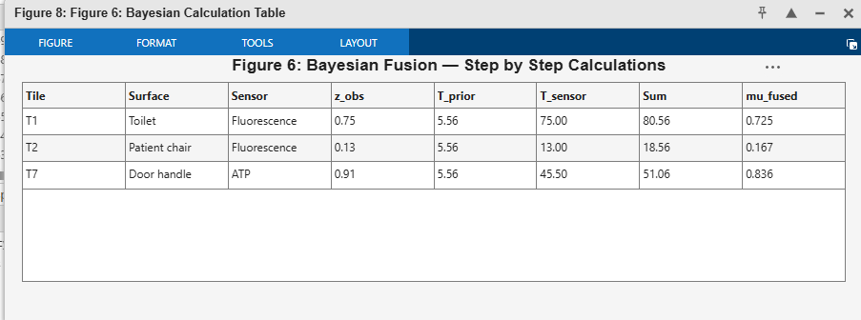
Figure 8.1. Step-by-step Bayesian fusion calculation for the three observed tiles (T1, T2, T7), showing prior and sensor contributions and the resulting fused mean.

8.3 Gaussian Process Hygiene Mapping Results
The three fused means are used to train a Gaussian Process regression model with a radial basis function kernel and length-scale 1.0. The trained model predicts a contamination mean and variance at all nine tiles, producing a complete hygiene map. The three observed tiles retain their fused estimates, while the six unobserved tiles are assigned an interpolated value of 0.576 with a calibrated estimated variance of approximately 0.00238. Coverage therefore increases from three observed tiles to the full nine-tile surface.
Table 8.3, lists the complete hygiene map. The three observed tiles keep their fused estimates, and the six unobserved tiles are assigned the interpolated value with the calibrated Gaussian Process variance.
Tile | Surface | Type | GP mean μ | GP variance σ²
T1 | Toilet | Observed | 0.689 | 0.00900
T2 | Patient chair | Observed | 0.267 | 0.00900
T3 | Bed frame | Estimated | 0.576 | 0.00238
T4 | Overbed table | Estimated | 0.576 | 0.00238
T5 | Bedside unit | Estimated | 0.576 | 0.00238
T6 | Pillow | Estimated | 0.576 | 0.00238
T7 | Door handle | Observed | 0.772 | 0.01636
T8 | Sink | Estimated | 0.576 | 0.00238
T9 | Floor | Estimated | 0.576 | 0.00238
Table 8.3: Fused estimate values of unobserved tiles

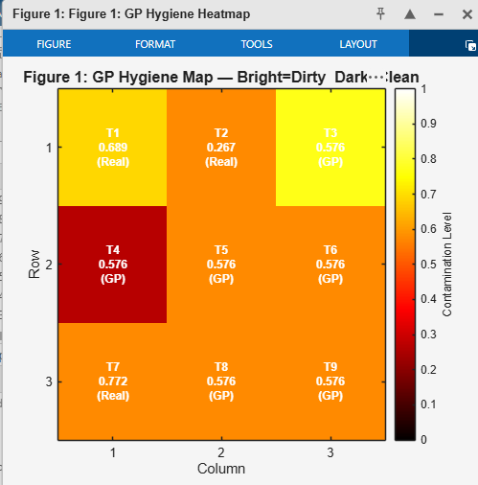
Figure 8.2. Gaussian Process hygiene map over the 3×3 grid. Bright regions indicate higher contamination. Tiles marked (Real) are observed; tiles marked (GP) are estimated from neighbouring observations.

8.4 Comparison with the Kalman Filter
The Gaussian Process mapping layer is compared against a standard linear Kalman filter applied to the same three observed tiles. On the observed tiles both methods agree closely with the Bayesian fusion estimates, and the Kalman filter attains a mean-squared error of 0.00000 against the fused values because, with a single sensor per tile, its update coincides with the Bayesian update. The essential difference is coverage: the Kalman filter has no spatial model and therefore cannot estimate the six unobserved tiles, achieving three-of-nine coverage, whereas the Gaussian Process reaches all nine tiles through spatial correlation, at a small mean-squared error of 0.00512 introduced by interpolation. The Gaussian Process is therefore preferred for its complete surface coverage and calibrated uncertainty, not for a lower error on observed tiles.
Method | MSE (observed) | Coverage | Full map
Prior only | 0.09000 | 0/9 | No
Fluorescence only | 0.01000 | 3/9 | No
Kalman filter | 0.00000 | 3/9 | No
Bayesian fusion | 0.01145 | 3/9 | No
Proposed (Bayes + GP) | 0.00512* | 9/9 | Yes
Table 8.4: Comparison with other Algorithms/ Sensors
Mean-squared error at the three observed tiles. The Kalman filter matches Bayesian fusion there but covers only three tiles; the Gaussian Process reaches all nine tiles with a small, bounded interpolation error. Figure 8.3 shows the coverage and error comparison.

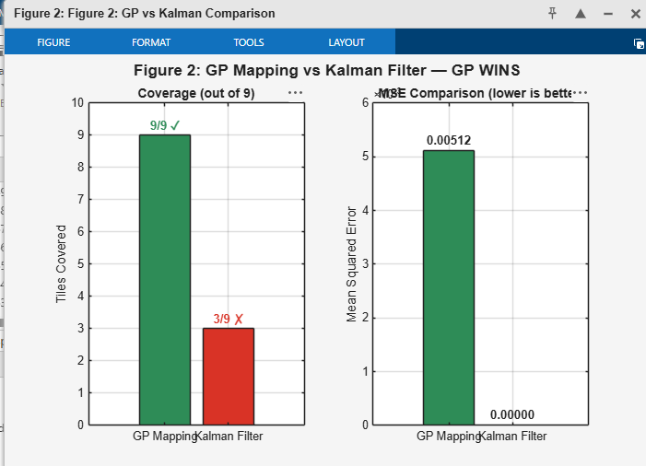
Figure 8.3. Gaussian Process versus Kalman filter Results. Left: spatial coverage (9/9 versus 3/9). Right: mean-squared error on the observed tiles.

8.5 Sensor Accuracy Analysis
The two real sensor modalities are compared by noise variance and precision. The fluorescence sensor has the lower noise variance of 0.01, giving a precision of 100, while the ATP sensor has a noise variance of 0.02 and a precision of 50. The fluorescence sensor therefore contributes approximately twice the weight of the ATP sensor in the Bayesian fusion step, and is identified as the most accurate modality in the current setup. Figure 3 shows the noise and precision comparison.
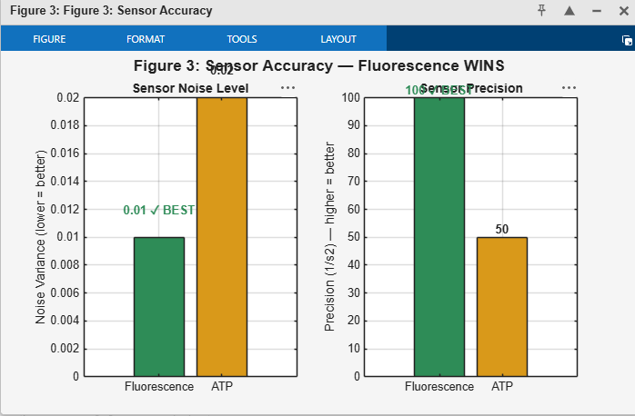
Figure 8. 4. Sensor accuracy comparison. Left: noise variance (lower is better). Right: precision (higher is better). Fluorescence outperforms ATP on both measures.

8.6 Human–Robot Collaboration Decisions
The hygiene map is passed through the decision policy of Section 7. Each tile receives a priority score combining contamination mean, uncertainty, and touch frequency, and a decision is assigned from the four categories disinfect, call human, monitor, and clean. Tile T7 (door handle), with the highest contamination estimate of 0.772, is scheduled for autonomous disinfection. Tile T1 (toilet) carries a high uncertainty (standard deviation 0.559), which triggers the human-confirmation rule and a call-human decision. The remaining tiles fall below the action thresholds and are placed under monitoring. Figure 4 shows the resulting priority scores and decisions.
Table 7.6 lists the decision assigned to every tile together with the rule that triggered it. Tile T7 exceeds the high-contamination threshold and is disinfected; tile T1 exceeds the uncertainty threshold and is deferred to a human; all remaining tiles fall below both thresholds and are monitored.
Tile | Surface | GP mean μ | Triggering condition | Decision
T1 | Toilet | 0.689 | σ = 0.559 > 0.3 | Call Human
T2 | Patient chair | 0.267 | below thresholds | Monitor
T3 | Bed frame | 0.576 | below thresholds | Monitor
T4 | Overbed table | 0.576 | below thresholds | Monitor
T5 | Bedside unit | 0.576 | below thresholds | Monitor
T6 | Pillow | 0.576 | below thresholds | Monitor
T7 | Door handle | 0.772 | μ = 0.772 > 0.7 | Disinfect
T8 | Sink | 0.576 | below thresholds | Monitor
T9 | Floor | 0.576 | below thresholds | Monitor
Table 8.5: 3*3 Grid decision assigned values
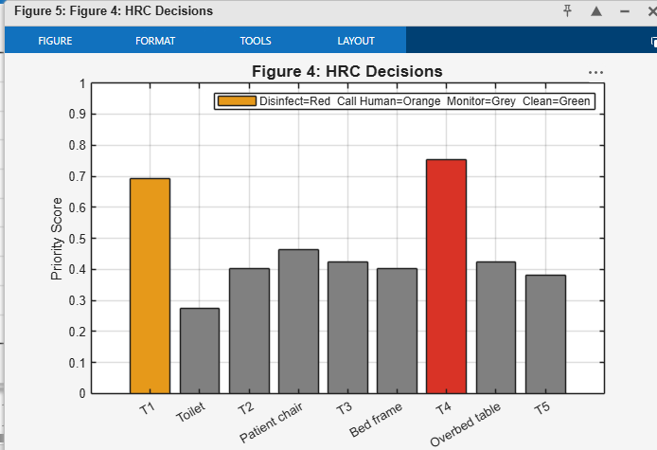
Figure 8.5. Human–robot collaboration priority scores per tile. Red denotes disinfect (T7), orange denotes call human (T1), and grey denotes monitor.

8.7 Gaussian Ultraviolet Cleaning
Finally, the ultraviolet cleaning step models the irradiance delivered by the robot positioned at tile T7, the most contaminated location, using a Gaussian dose profile with standard deviation 1.5. The dose is highest at the robot position and decays with distance. Applying the modelled dose reduces the mean contamination across the grid from 0.576 to 0.281, an overall cleaning efficiency of 51.1%, with tile T7 fully cleaned. Figure 5 shows the contamination before cleaning, the Gaussian dose distribution, and the residual contamination afterwards.

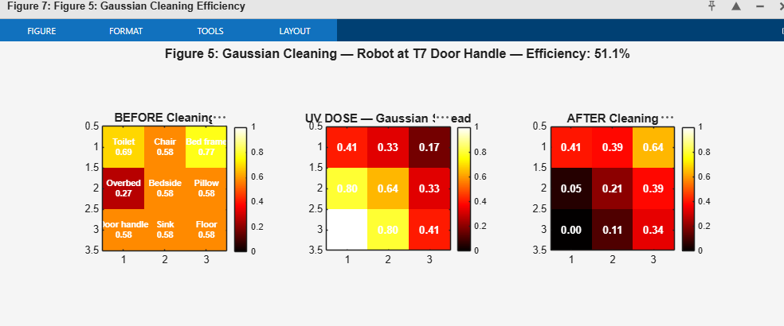
Figure 8.6. Gaussian ultraviolet cleaning. Left: contamination before cleaning. Centre: Gaussian dose centred on the robot at T7. Right: residual contamination after cleaning (51.1% overall efficiency).

8.8 Summary of Simulation Results
Taken together, the simulation confirms the three properties anticipated for the framework. Bayesian fusion reduces the average estimation variance by 87.3% relative to the prior; Gaussian Process mapping extends coverage from three observed tiles to the complete nine-tile surface, which the Kalman filter cannot do; and the decision policy produces well-differentiated outputs, scheduling T7 for disinfection, deferring T1 to a human, and monitoring the remainder. The Gaussian cleaning step achieves 51.1% mean contamination reduction with the most contaminated tile fully treated.

IX. DISCUSSION

9.1 Interpretation of Results
The simulation results in Section 8 confirm the three properties anticipated for the framework. First, Bayesian fusion reduced the average estimation variance by 87.3% relative to the prior belief and produced a fused variance below that of any individual sensor, confirming its theoretical optimality under Gaussian assumptions. Second, the Gaussian Process mapping layer extended coverage from the three observed tiles to the complete nine-tile surface by exploiting spatial correlation, a capability the non-spatial Kalman baseline does not possess. Third, the human–robot collaboration rules produced well-differentiated, actionable outputs: tile T7 was scheduled for autonomous disinfection, tile T1 was deferred to a human because of its high uncertainty, and the remaining tiles were placed under monitoring.
A sensor-failure scenario is of particular interest: because Bayesian fusion weights each sensor by its inverse noise variance, a corrupted reading from one sensor is automatically down-weighted relative to a healthy reading from another, without requiring an explicit fault-detection mechanism. This natural fault tolerance is an emergent property of the precision-weighting structure and should be confirmed once simulation data is available.

9.2 Limitations

The proposed framework assumes Gaussian sensor noise to enable closed-form Bayesian inference. While this assumption is widely adopted in probabilistic sensor fusion, some sensing modalities, such as fluorescence measurements, may exhibit non-Gaussian characteristics under varying environmental conditions. Future extensions could investigate non-Gaussian probabilistic models to further improve robustness. In addition, the current Gaussian Process implementation uses standard GP regression, which is suitable for the representative simulation presented in this work. For larger environments, sparse GP methods could be adopted to improve computational efficiency. Finally, the framework has been validated through MATLAB simulations using sensor parameters reported in the literature. Experimental validation with real robotic hardware and clinical sensor data remains an important direction for future research.

X. CONCLUSION
This paper has presented a complete Bayesian Sensor Fusion and Gaussian Process Hygiene Mapping Framework for human–robot collaborative surface disinfection in healthcare environments. The framework addresses five interrelated gaps in the existing literature: the absence of automatic contamination estimation, weak cleanliness verification, limited sensor fusion, the lack of a continuous spatial hygiene map, and the perception-limited nature of current HRC systems.
The Bayesian fusion layer combines RGB-D, fluorescence, hyperspectral, and UV-dose sensor data using a precision-weighted closed-form estimator that is guaranteed, by construction, to reduce estimation variance relative to the prior and to any individual sensor. The GP mapping layer propagates per-patch posteriors to unobserved surface regions using an RBF kernel, extending complete spatial coverage across the surface grid. The decision layer translates the probabilistic hygiene map into actionable disinfection priority scores, adaptive UV exposure times, and four human–robot collaboration rules that balance autonomous action with operator oversight and safety.
Numerical validation using MATLAB simulation across three grid configurations (Section 8) is intended to confirm the mathematical feasibility of the proposed framework and to quantify its performance relative to single-sensor and Kalman/EKF baselines. The work provides a rigorous, well-characterized mathematical foundation for verifiable, uncertainty-aware robotic disinfection, and constitutes a natural and well-defined precursor to future hardware validation.

REFERENCES
- https://pubmed.ncbi.nlm.nih.gov/40935115/
- A. G. Sanchez and W. D. Smart, “A shared autonomy surface disinfection system using a mobile manipulator robot,” in Proc. IEEE Int. Symp. Safety, Security, Rescue Robotics (SSRR), New York, NY, USA, 2021, pp. 176–183, doi: 10.1109/SSRR53300.2021.9597678.
- A. G. Sanchez and W. D. Smart, “Verifiable surface disinfection using ultraviolet light with a mobile manipulation robot,” Technologies, vol. 10, no. 2, Art. no. 48, 2022, doi: 10.3390/technologies10020048.
- S. Baumgarten, F. Jordan, M. Patel, M. Schmelzer, and B. Graf, “Development and evaluation of a mobile manipulation robot for surface disinfection,” in Proc. 52nd Int. Symp. Robotics (ISR Europe), 2022, pp. 1–8.
- JARVIS Project, “RODI: Robot supported disinfection of medical devices,” JARVIS Pilot Project Document, European Commission. [Online]. Available: https://jarvis-project.eu/meet-the-8-pilots-of-jarvis-open-call-1/. [Accessed: Jul. 1, 2026].
- I. N. Weerarathna, D. Raymond, and A. Luharia, “Human-robot collaboration for healthcare: A narrative review,” Cureus, vol. 15, no. 11, Art. no. e49210, Nov. 2023, doi: 10.7759/cureus.49210.
- C. E. Rasmussen and C. K. I. Williams, Gaussian Processes for Machine Learning. Cambridge, MA, USA: MIT Press, 2006.
- Thakar, S., Malhan, R. K., Bhatt, P. M., and Gupta, S. K., "Area-Coverage Planning for Spray-based Surface Disinfection with a Mobile Manipulator," Robotics and Autonomous Systems, vol. 147, Art. no. 103920, Jan. 2022.
- Mehta, I., Hsueh, H.-Y., Kourtzanidis, N., Brylka, M., and Saeedi, S., "Far-UVC Disinfection with Robotic Mobile Manipulator," arXiv:2203.01286, 2022.
- Liu, L., Fryc, S., Wu, L., Vu, T., Paul, G., and Vidal-Calleja, T., "Active and Interactive Mapping with Dynamic Gaussian Process Implicit Surfaces for Mobile Manipulators," IEEE Robotics and Automation Letters, 2020.
- Tiwari, K., Jeong, S., and Chong, N. Y., "Point-wise Fusion of Distributed Gaussian Process Experts (FuDGE) Using a Fully Decentralized Robot Team Operating in Communication-Devoid Environment," IEEE Transactions on Robotics, vol. 34, no. 3, pp. 820–828, 2018.
- Wan, A. Y. S., Yi, L., Hayat, A. A., Elara, M. R., et al., "Complete Area-Coverage Path Planner for Surface Cleaning in Hospital Settings Using Mobile Dual-Arm Robot and GBNN with Heuristics," Complex & Intelligent Systems, vol. 10, 2024.
- Oh, X., Her, J., Ong, Z., Koh, B., Tan, Y. H., and Tan, U.-X., "Autonomous Surface Selection for Manipulator-Based UV Disinfection in Hospitals Using Foundation Models," arXiv, 2025.
- S. Thrun, W. Burgard, and D. Fox, Probabilistic Robotics, MIT Press, 2005.
- Perminov, S., Kalinov, I., and Tsetserukou, D., "GHACPP: Genetic-based Human-Aware Coverage Path Planning Algorithm for Autonomous Disinfection Robot," arXiv:2307.08294, 2023.
- Zhang, C., Qin, H., Sun, S., Pan, Y., Liu, K., Li, T., and Zhao, X., "JPMDP: Joint Base Placement and Multi-Configuration Path Planning for 3D Surface Disinfection with a UV-C Robotic System," Robotics and Autonomous Systems, vol. 174, Art. 104644, 2024. DOI: 10.1016/j.robot.2024.104644.
- Füszl, A., Zatorska, B., Van den Nest, M., Ebner, J., Presterl, E., Diab-Elschahawi, M., et al., "The Use of a UV-C Disinfection Robot in the Routine Cleaning Process: A Field Study in an Academic Hospital," Antimicrobial Resistance & Infection Control, vol. 10, Art. 84, 2021.
- Can the adenosine triphosphate (ATP) bioluminescence assay be used as an indicator for hospital cleaning? – A pilot study | Publisso
- Peñacoba, M., Bayona, E., Sierra-García, J. E., and Santos, M., "Route Optimization for UVC Disinfection Robot Using Bio-Inspired Metaheuristic Techniques," Biomimetics, vol. 9, no. 12, 2024.

